Immigration Dave Watson
Devolving Immigration Powers
Of all the powers that might be devolved to Scotland, immigration is intuitively an unlikely candidate. Borders are created at the nation-state level to maintain the free movement of goods and people throughout the UK. The problem with this arrangement is that different parts of the UK have differing needs for immigration that are not accommodated in the current ‘one-size-fits-all’ model.
This challenge is not unique to the UK, and other countries have established mechanisms to allow for varying levels of devolution. In this paper, we make a case for at least the partial devolution of immigration powers to Scotland.
The case for immigration
There is clear evidence that immigration has had a positive impact on the economy and the delivery of our public services. Migrants have a higher employment rate than people born in the UK, are less likely to claim benefits or use the NHS. Skilled migrants can boost innovation, stimulate economic growth and encourage the local labour force to invest in training to specialise in jobs in which the nation or region has a comparative advantage. See Table 1
There is arguably nowhere in the UK where the economic and social case for immigration is more robust than in Scotland. Our working-age population is not projected to increase at the same rate as the rest of the UK, and the numbers of working-age Scots to support our ageing population won’t be available without immigration. Since 2007, Scotland has relied on migration for population growth more than any other region in the UK. 63% of Scotland’s growth is attributed to immigration, compared to 53% of the rest of the UK as a whole. Brexit and UK immigration policy threaten this population growth with adverse economic consequences and staffing of our public services.

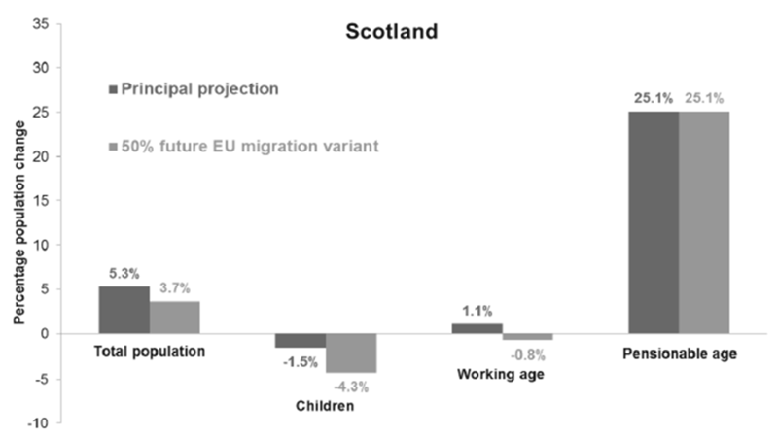
Table 1
Policy interventions to support new births have a limited impact and are long-term solutions at best. The only short-to-medium term measures to grow the working-age population are increasing inward migration or raising the state pension age.
The pandemic restrictions have added to these pressures and employers are warning that the end of furlough will not release the number of workers needed to fill vacancies. UK Government visa programmes favour degree-level professionals while side-lining service and trade occupations. The Scottish Hospitality Group is calling on Westminster to work with the three devolved nations to introduce a migrant visa scheme for these groups.
Immigration frameworks
Devolved immigration initiatives have been deployed in Scotland, most notably through the Fresh Talent initiative introduced by the then First Minister, Jack McConnell, in 2004 to counter Scotland’s falling population. This limited initiative was aimed at encouraging overseas students to stay in Scotland when they completed their courses.
Dr Eve Hepburn set out three sets of levers for differentiating the UK’s immigration system in a paper for the Scottish Parliament’s External Relations Committee in April 2017.
Soft levers such as migrant integration, awareness and education have been an important part of successive Scottish government policies to encourage migration to Scotland and ensure its success. Examples include One Scotland - Many Cultures, New Scots, and Welcome to Scotland, introduced under existing powers. Economic, political and social initiatives would also help ensure that migrants stay, but they don’t address the need to allow migration into Scotland.
Mid-range levers include working with the UK Migration Advisory Committee (MAC) to create a Scotland-specific Shortage Occupation List (SOL). In practice, the variations in the Scotland-specific shortage list have been limited. In any case, short-term migration programmes only address perceived temporary skill shortages. Scotland has long-term demographic challenges that will not be addressed in a short period. Temporary systems, also, do not encourage a high level of integration. The devolution of administrative competencies of the sort that exist in Canada, Finland and Switzerland can help address the backlog in immigration processes. However, the focus should be on substantive powers that deliver the desired outcomes rather than simply on the process.
Hard levers would involve devolution of exclusive competencies over immigration on the Canadian or Quebec model – even if that is within an agreed framework of regional visas. The main criticism of this approach is the risk of leakage of migrants to other parts of the UK once the geographical limitation period comes to an end. The international evidence in the Hepburn Report shows that high retention rates can be achieved. Scotland is not an isolated, low wage, underdeveloped nation, comparable to regions in other countries that have sustained lower retention rates. There is a good quality of life, a developed economy, and a generally welcoming population. While we need to do more on these issues, these factors favour the higher retention rates we have seen internationally – as high as 90% in Quebec.
Approaches to asylum and refugee policy varies internationally with some devolving the competence and others reserving this category to the nation state. There is no practical reason for treating refugees any differently from other migrants, and even under the hard levers approach this could be done within a policy framework agreed between the devolved administrations and the UK Government.
The way ahead
While the soft and mid-range levers outlined above can contribute to better outcomes, we believe that hard-range levers will also need to be adopted, given Scotland’s demographic challenges. The Scottish Government proposes a Scottish visa to enter the UK that would let migrants live and work in Scotland, with a Scottish tax code. This would be similar to the Canadian Province Nominee Programme (PNP), which is not quite as extensive as the Quebec model. Holders of the Scottish visa would have to live in Scotland and could not live elsewhere in the UK. They argue that Scottish Ministers should set this. However, there would need to be a dialogue mechanism with the UK Government. This would be a partial devolution of immigration, sharing responsibility within the UK. The Scottish Government paper also makes a case for rural pilot schemes to address population change in our most remote rural and island communities.
The chart below shows how the system could operate. Table 2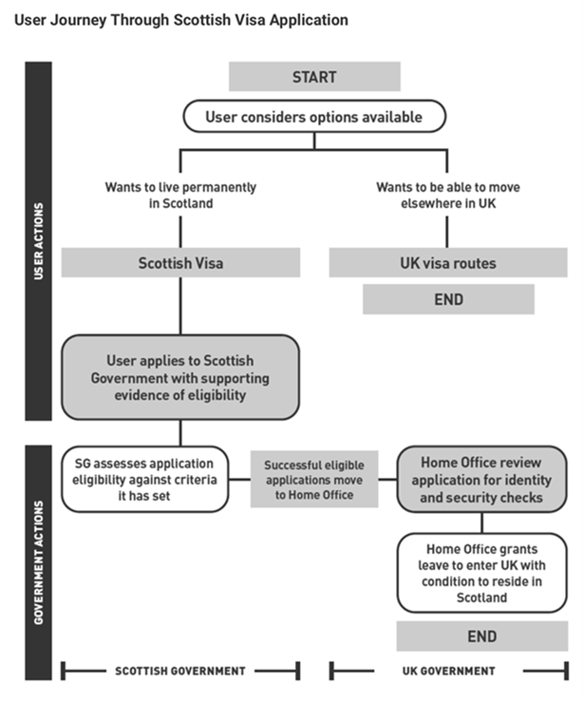
This approach has broad support within Scotland, including business organisations and trade unions. The STUC said, “Bespoke visa schemes for Scotland, combined with expanding international outreach activities in relation to immigration to advertise these new arrangements, would be an effective way of ensuring that immigration policy meets Scotland’s needs.”
The Mayor of London has also made a similar case for London-only visas, supported by business and trade unions.
Opinion poll data shows that while concern for immigration has risen in all parts of the UK in the last five years, it is consistently less concerning to residents in Scotland and London. The Kenmure Street action in Glasgow when the local population took action to prevent two local residents being taken to a detention centre, highlights community support for a different approach. Devolution would also place responsibility for enforcement with the Scottish Government, addressing any perception that immigration is simply used to generate political grievances.
Conclusion
The partial devolution of immigration powers on the model set out above could address Scotland’s specific demographic challenges. The UK Government’s claim that this is impossible without internal borders is not supported by international evidence. A shared responsibility would allow the policy to be introduced gradually, providing an evidence base for further action.

